**Discussion 1**

Recall that the solution to a quadratic equation, ax2+bx+c=0,

can be solved by using the formulae

Consider the quadratic equation 5x2+6x+1=0, List the steps for a human being to solve for 𝑥

**Discussion 2**

List the steps for a computer to solve problem 1.

**Discussion 3**

1. What are the functions of each of the units shown in the CPU diagram below.
2. Briefly describe the CPU Instruction Execution Cycle using the example of an instruction A black and white math equation

   Description automatically generated with medium confidence

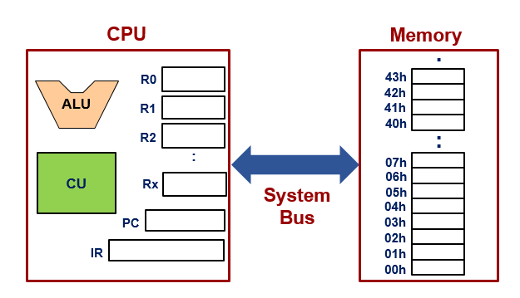

**Discussion 4**

Assume the following:

* The ALU in the diagram above is capable of performing addition, subtraction, multiplication, division, negation, and square-root operations.
* The result of the ALU computation cannot be immediately stored into the source registers of the computation.

With the fewest possible registers used, show the typical steps that the CPU will use to execute an instruction to compute:

